PRESS RELEASE

FAMOUS BANGKOK RESTAURANT GROUP CELEBRATES SUCCESS OF ITS RIVER CRUISE WITH LAUNCH OF GORGEOUS NEW RIVERSIDE RESTAURANT

(NEW YORK—June 9, 2017) — Supanniga Group, restaurant proprietor of the famous Michelin-rated restaurant Somtum Der, and the award-winning Supanniga Eating Room Bangkok in Thong Lhor and Sathorn (supannigaeatingroom.com), recently launched Supanniga Cruise (supannigacruise.com) where diners indulge in the authentic tastes of regional Thai cuisine while cruising along the Chao Phraya River and enjoying the magnificent scenery of Bangkok’s historical sites. Given its intimate setting and scrumptious menu, the Supanniga Cruise has quickly become a must-experience excursion for foodies, discerning tourists and Bangkok locals alike since it launched in December 2016.

The 40-seat dinner and sunset cocktail cruise offers two exciting options: Evening Cocktail Cruise and Evening Champagne Cruise for enjoying beverages and light Thai fare; or its Sunset Six-Course Dinner Cruise for those who want to indulge in exquisite and authentic Thai dishes for a memorable night in Bangkok.

This July, the group will be launching a brand-new riverside restaurant: Supanniga Eating Room by Khun Yai x Roots Coffee. Situated on the riverfront of Riva Arun, this charming boutique hotel by Chao Phraya River offers a magnificent view across the river of Wat Arun (AKA Temple of Dawn), one of Bangkok’s most famous landmarks. The new restaurant will serve up Supanniga Eating Room’s most popular authentic Thai dishes like Pu Jah (blended crabmeat and pork seasoned with purely refined pepper from Chantaburi that is steamed inside the crab’s shell); Khao Krieb Nahm Jim (steamed flat rice noodle with a spicy dried shrimp dressing); Panang Nue Lai (beef chunk red curry topped with fresh coconut and chopped kaffir lime leaves); and Moo Cha Muang (chunks of tender pork meat stewed with Thai herbs and Cha Muang leaves)—a rare eastern Thai delight!

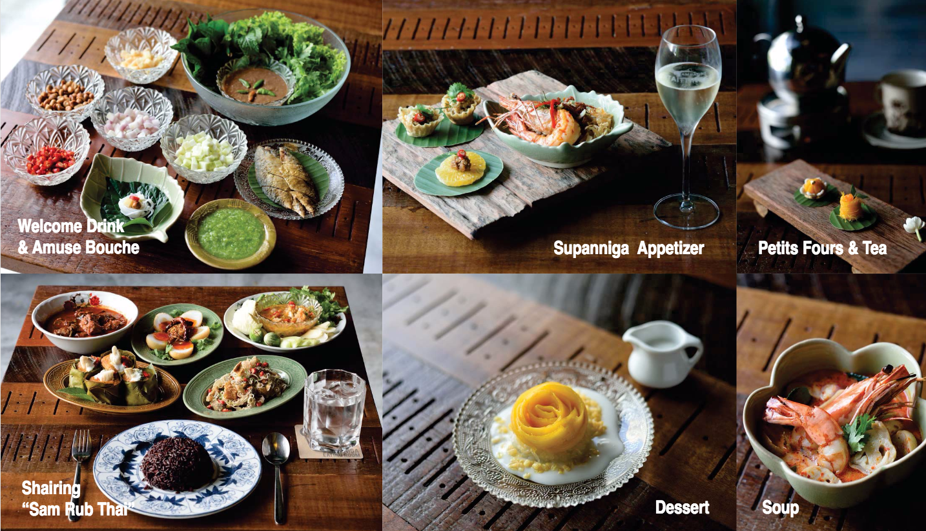

Supanniga Eating Room (supannigaeatingroom.com) was recently announced as a recipient of TripExpert’s “Experts’ Choice Award” and “Best of Bangkok” in April 2017. TripExpert is a New York City-based company that offers comprehensive reviews of the best places to experience, stay, and dine in cities around the world. TripExpert’s ratings are based on reviews from more than 70 respected travel publications, and has become a premier source for its ratings and respected experts’ opinions.

About Supanniga Group
Supanniga Group is committed to bringing authentic, regional Thai cuisine to the world. The group began with its first restaurant, Krua Supanniga by Khun Yai at Supanniga Home, which opened its doors in the Khon Kaen province in 2012. The concept is to bring back a grandmother’s eastern-region recipes and combine these with Isan cuisine. Today, the group has come to dominate the Bangkok restaurant scene with several brands, including Supanniga Eating Room, EAT All Thai, EAT Rice & Noodle, the Michelin-rated restaurant Somtum Der (now available in Bangkok, NYC, Ho Chi Minh City; with Tokyo and Beijing opening later in 2017)—and its most recent launch: Supanniga Cruise. For more info, please visit: supannigagroup.com

Media contact:

Kate Hasenfus / Milestone PR

Email: kate@milestoneprnyc.com

